*A project on*

**PREPARATION OF THIOKOL RUBBER**

*submitted*

***to***

**Dr. Suman**

**Assistant Professor (Chemistry)**

**By**

**T.BABITHA REDDY**

22881A6658

Course: Engineering Chemistry Laboratory (A8009)

Semester: II

Branch& Section: Computer Science and Engineering Artificial Intelligence & Machine Learning (CSE AIML) A



**HUMANITIES & SCIENCE (H& S)**

**VARDHAMAN COLLEGE OF ENGINEERING, KACHARAM, SHAMSHABAD, HYDERABAD, TELANGANA,**

**INDIA – 501218**

THIOKOL RUBBER

OBJECTIVES:

1. To synthesize an organic synthetic rubber by condensation reaction.

2. To examine the concept of polymerization.

APPARATUS:

1. Conical flask (250 ml) - 1 No.
2. Beaker (250 ml) - 1 No.
3. Funnel - 1 No.
4. Measuring jar (10 ml) - 1 No.
5. Glass rod - 1 No.
6. Filter paper - 1 No.
7. Water bath - 1 No.

CHEMICALS:

1. 1,2-dichloro ethane
2. NaOH
3. Sulphur powder

PRINCIPAL:

Thiokol rubber is a condensation product of Ethylene dichloride and Di Sodium polysulphide

REACTION:

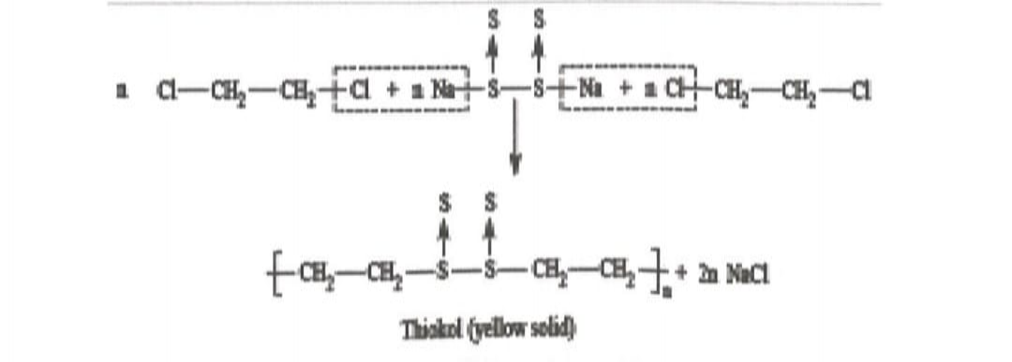

Figure: Condensation of 12-dichloro ethane and sodium polysulphide

PROCEDURE:

6 gm powdered sulphur is added to a warm solution of NaOH ( 3g dissolved in 60-70 ml of water) with constant stirring .A deep red solution is obtained. The remaining insoluble sulphur is to be filtered off. Now add 15 ml of 1,2-dichloro ethane to the clear solution with continuous stirring. The mixture is mixed for 15-20 minutes. The rubber separates out as a lump. The supernatant liquid is decanted and the product is washed under the tap. It is dried within the folds of a filter paper and weighed

PROPERTIES:

1. Thiokol is resistant to the action of oxygen and ozone.
2. It is also resistant to the action of petrol , lubricants , and other organic solvents.
3. Thiokol films are impermeable to gases to a large extent.
4. It cannot be vulcanized due to absence of unsaturation in the backbone.

APPLICATIONS:

1. Used in manufacturing of barrage balloons , life rafts and jackets.
2. Employed in moulding chemical carrying pipes , especially gasoline or petrol.
3. Used as a tank liner in oil storing containers.

OUTCOMES:

Upon completion of the experiment, the student able to

1. Develop synthetic rubber by condensation reaction.
2. Apply the knowledge of synthetic polymers in hardware industries.